NHB+ Creating MOAT

Mindset

What have you failed at?

- NOTHING

Now, I’m going to show you why you’ve NEVER failed at anything in life either.

Every time you had / have “failure” you reframed your entire timeline to recreate your future through a new lens, which propagates new limitations that are based on the failure.

Being failure is your “new truth”

Failure = I can’t
- I don’t want to = choice
- I don’t know how
  - If I don’t know how
    - I don’t want to know how = choice

So knowing this, you know got exactly what you wanted, because you chose it.

You go back and do this

- You never failed
- You never did anything wrong
- You were never limited
- You never fuck ed up

When we eliminate these sources that come from “FAILURE”, your identity boosts a lot.

When you fail = you are a failure.



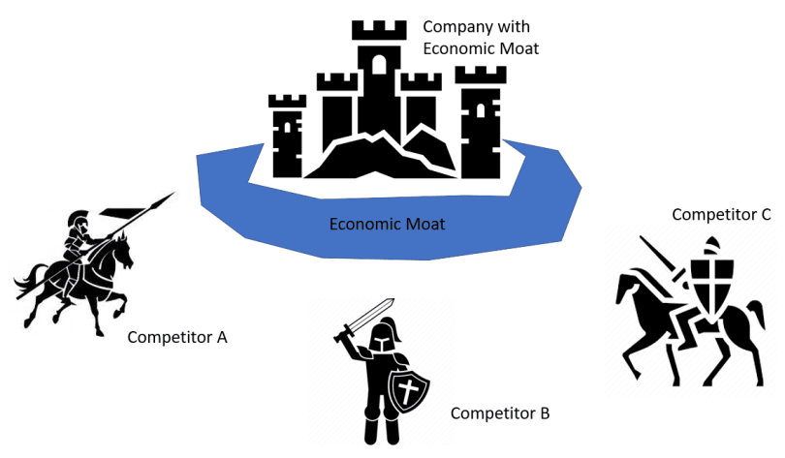

Most people in the game are focused on just generating customers.

The ONLY constant that holds true is that the cost of ads continue to go up.

If you look at any type of economic breakthrough in DR / Marketing it’s a new tech platform with cheap ads.

Facebook - 2014 cheap ads
Google 2004 - 2 cents a click
TikTok - cheap ads
Etc…

So long as you have cheap ads, you can make good money, pretty easily.

If everyone has access to the same advantage, soon enough that advantage will become a disadvantage.

If the cost of ads goes up, which it will, there’s only one thing to do, which is scale in the negative.

If ads go up, you have to lose money to make money.

Then the game becomes about whoever is BEST at losing money is going to make the most money.

It becomes all about “deep back ends” and repeat customers.

It’s all going to become repeat business.

Those who have repeat business = win, those who do not = lose.

Those that do this 1st, take position in the market to own the market.

Warren Buffet said:

“I couldn't pay you $10k NOT to use an iphone”

So if someone can pay your customers NOT to do business with you, then you have zero moat.

Because we operate in OPEN MARKETS and as such anyone, anywhere can run and POACH your customers.

But when they run ads, the customer has to pay THEM, so if they can’t pay your customers to leave, you never have to think about it.

This brings the risk of the business to be virtually zero.

At some point you have to get good at product, otherwise without product you have no business.

So in a sense, you’re not paying to acquire the customer.

You are paying to acquire the revenue.

Now with revenue, there are two types of revenue:

- Revenue - this is the only time you pay and lose.
- Repeatable Revenue

Just so happens that that revenue comes from people.

What’s the potential revenue here from this person?

MLTV, maximum lifetime value of customer = $100k.

The more MOAT you have, the more revenue you can actualize.

To do that you need to create MOAT

The distance between you, your customers and your competitors.

Time, money and energy is all one.

These are the 3 resources any human being needs.

Human being = living entity.

Living entity = corporation.

You can always combine 2 of these to get the 3rd, to be complete.

Rarely do you have all 3.

Time + Money = you can get energy

Money + Energy = you can get time

Energy + Time = Money

What is the distance between you and the competitors?

Time, Money, Energy.

Time = How long would it take for someone to get to where you are?

Time is mostly yours, but can be someone else's

Money = How much money would it take for someone to get to where you are?

Can be yours or someone else's

Energy = How much energy would it take for someone to get to where you are?

Yours or someone else's

The 1st rule of moat is SECRECY

If they don't know how much you make, they will not be able to calculate the payoffs and the costs above against it.

They don’t know how it’s made, then once again they can not extrapolate how much time, money and energy it would take to get it.

 | Low Level | High Level Scale / High Velocity
Energy / Thought | Yours | Theirs / Others
Time | Yours | Theirs / Others
Money | Yours | Theirs / Others

Level 1:

Acquisition of Capital, Allocation of Capital and Multiplication of Capital

Entrepreneurs acquire capital
Banks / investors allocate
Investors multiply

1. Acquisition of Capital - 1m
- Selling things
  - Sell our TIME
    - Copywriters
    - CMOs
    - Etc..
  - Sell our Products
    - In order to sell product, you have to CREATE product
    - Offer owners
- Borrowing
- Getting investor / raising capital

2. Allocation of capital - 100m
- How do you spend money?
  - Is on product
  - Team
  - Research
  - Resources
  - etc…

3. Multiplication of capital - 1b

The process to wealth

Acquire capital, allocate it to get more time, money and energy, and then use that to create systems that cause a multiplication effect to scale

Level 2:

1. Acquisition of time - 1m
- Who has the time?
  - People have it
  - Machines have it
2. Allocation of time - 100m
- Management
  - Where does it go?
3. Multiplication of time - 1b

Level 3:

1. Acquisition of thought - 1m
- Who has the thought?
  - Talent has the thought
  - Where does that thought go?
2. Allocation of thought - 100m
- What do you focus this on?
- This causes it grow
3. Multiplication of thought - 1b
- Acquires more money, and then you can multiply thought

Everything comes out of time

- Thought
  - Knowledge
    - This is an advantage
- Energy
  - Ai is removing this
- Money
  - This is a competitive advantage

Level 4: Terms thinking

- I goto gym owner “I want to buy the gym”
- Gym owner says “Ok $5m”
- Normal thinking is “$5m cash, FUCK”
- Terms thinking is “I’ll give you $1m cash, and you have $50k a month NET, I’ll use this to finance $4m”, based on rates whatever…I’ll take $25k over X years to pay it back.
- I keep $25k a month net leverage income. To pay off my $1m
- 2.5% return on capital
- I can sell a license or a franchise of it for $1m to someone in 5 cities around me.
- That brings me $1m cash.
- I can also get say 10% of their revenue, I got 50% revenue combined
- $50k coming in
- $1m x 5 = $5m in
- I get my $1m back, and now I got cash flow and everything coming to me.
- $4m put it in the market, you get 7% = $280,000 / year income.

